Welcome to our practice!
Please help us serve you better by taking a few minutes to provide the following information.
Name: |  |  |  |  |  |  |  | Today’s date:
 | Last Name |  |  | First Name
Address:
City / State / ZIP:
Phone # | MOBILE |  |  |  | HOME |  |  |  | WORK
DOB: |  |  |  |  |  | Age: |  |  | Marital status: | M | S | W | D
Email:
Occupation: |  |  |  |  |  | Employer:
Emergency Contact |  | Name: |  |  |  | Phone:
Primary Care Physician |  | Name: |  |  |  | Date of next visit
Specialist Physician |  | Name: |  |  |  | Date of next visit

How did you hear about our practice?
Who can we thank for referring you to our practice?

The following is very important in our evaluation process.
Please fill out these forms as specifically as possible to provide us with a clear picture of your present pain and functional status.
What is the primary issue/problem that brings you in today? | Please shade in areas where you have pain, discomfort, or tension.  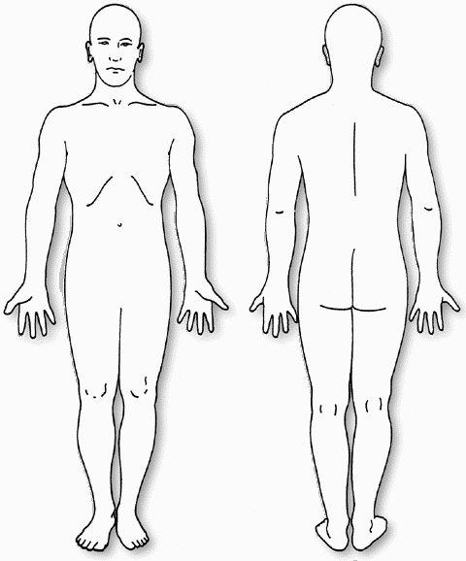
Secondary concern/problem?
As a result, I am now having difficulty with:
Are you currently experiencing pain as a result of these symptoms? If yes, what is it like?
When did your symptom(s) begin? (Date):

Please rate your pain in the last 24-72 hours  Using the “0 -10” scale where 0 is no pain and 10 is the worst possible pain. | At its worst
 | At its best
 | At present
 | Night (sleeping)

At what time of day are your symptoms the worst?
At what time of day are your symptoms the best?
What activities increase your pain?
What activities decrease your pain?

What other types of treatment have you had for this problem?
 | Massage |  | Bodywork |  | Physical Therapy |  | Myofascial Release |  | Chiropractic |  | Surgery
Other Medical Treatment: (Please Describe)

Check the box if you have had any of the following medical conditions?
 | Diabetes |  | Lung disease |  | Weight change |  | Varicose veins |  | Neurological problems |  | Pregnancy
 | Rheumatic fever |  | Osteoporosis |  | Migraine headaches |  | Epilepsy / seizures |  | Stroke |  | Blackouts
 | Heart Murmur |  | Malignancy |  | Arthritis |  | Broken bones (fracture |  | Metal implants |  | High blood pressure
 | Circulatory problems |  | Liver disease |  | Heart disease / pacemaker |  | Kidney disease |  | Others (explain below)

List past medical history and dates of occurrence. Include surgeries, accidents and other traumas.

List ALL medications which you are currently taking, the condition for which you are using them, the dose, and their effectiveness. (Include supplements, herbal and homeopathic remedies).
Medication | For treatment, of | Dose / Amount per day | Effectiveness

Do you smoke? | Yes | No | If “Yes” – How much?
When did you quit? |  |  | If not, would you like to quit?

Is there a chance you may be pregnant at this time? | Yes | No

Do you engage in regular exercise? |  | Yes | No
What type and how often?
Are you able to exercise now? |  | Yes | No

Do you have discomfort, shortness of breath, or pain with exercise? |  |  |  |  | Yes |  | No
Please Describe:
In general, your lifestyle is: | 1 | 2 | 3 | 4 |  | 5
 | Active |  | Average |  |  | Inactive

If sleep is a problem, answer these questions:
Do you have trouble falling asleep? | Yes | No | Do you find it difficult to change positions in bed?
Is your sleep restful? | Yes | No | How many times do you wake in the night?
Do you find it difficult to lie down? | Yes | No | How long before you fall back to sleep?

List all the Tasks / Activities that you have difficulty performing and your tolerance (minutes/hours).
If you are no longer able to perform an activity, your tolerance would be “0”.
Task / Activity | Tolerance (minutes/hours)

I walk for |  | minutes before needing to rest
I stand for |  | minutes before needing to sit
I sit for |  | minutes before needing to change positions/get up
Do you have trouble getting up from a chair? |  |  | Yes | No
Do you have trouble putting on your shoes and socks? |  |  | Yes | No
Do you have difficulty climbing stairs? |  |  | Yes | No

Patient Goals
Please list the activities that you would like to be able to do as a result of therapy.
Task / Activity | Duration / How Often | By When
Other Goals? Please use this section to share anything pertinent to this treatment.

INFORMED CONSENT

I recognize that I am protected by patient privacy laws and hereby authorize Dr. Barbara S Rabin PT, DPT, ATC, PYT of Holistic Physical Therapy (HPT) to only release my records to my referring physician's office for the purposes of facilitating improved quality and continuum of care.

Photographs, if taken during initial evaluation, progress evaluation and/or discharge summary will be used for postural comparison purposes and as educational tools. By signing below, I consent to the use of these photographs in a professional manner.

I do hereby declare myself to be physically sound and suffering from no condition, impairment, disease, infirmity, or other illness that would limit my participation. I acknowledge that I have either had a physical examination and been given my physician’s permission to participate, OR that I have decided to participate in the activity without the approval of my physician and do hereby assume all responsibility for my participation and activities.

I do hereby agree and give my consent for HPT to furnish care and treatment that is considered necessary and proper in the diagnosing or treating of my physical condition.

I understand and am aware that strength and flexibility exercises associated with physical therapy can be a potentially hazardous activity. I am voluntarily participating in these activities.

I understand that I retain the right to revoke this consent by notifying HPT in writing at any time.

I hereby certify that all the above information is true to the best of my knowledge.

PAYMENT POLICY

Holistic Physical Therapy is an enrolled provider with Medicare and several insurance plans. If you choose to submit to your insurance company, HPT will call said company to determine your benefits for physical therapy prior to your first visit. Whether submitting to an insurance company or not, all payment is required at the time of each visit. The exception is for Medicare recipients who do not pay HPT upfront beyond copays or deductibles. Payment can be by cash or check. Clients submitting to their insurance, are responsible for all co-payments, deductibles, and/or denials. Clients paying cash that want to submit to their insurance company for reimbursement can request a super bill receipt to be prepared for a one-time fee of $25.00. There is no guarantee as to what amount of the claim you will be reimbursed.

CHECK or CASH accepted and payable to: Barbara Rabin

The HPT sessions I will participate in have been fully paid for in advance according to the above payment policy.

CANCELLATION POLICY

Appointments must be cancelled or rescheduled 24 hours in advance. This is so we can schedule another patient who may need the time slot. In the event of a “no-show” or missed appointment a $25 late fee will be charged.

Out of respect for the staff and other patients, please make every effort to arrive on time for your appointments. Please phone or text and let us know if you are running late to 440-823-7514

Patient/Parent/Guardian Signature: _________________

Date: _________________

Edited 4/3/2019

